INVITATION
in the context of an educational program for the 2017 season Aikido Club Branik Maribor organises Tendoryu Aikido seminar led by international master Mr. Robert Hundshammer 5.DAN from Germany.
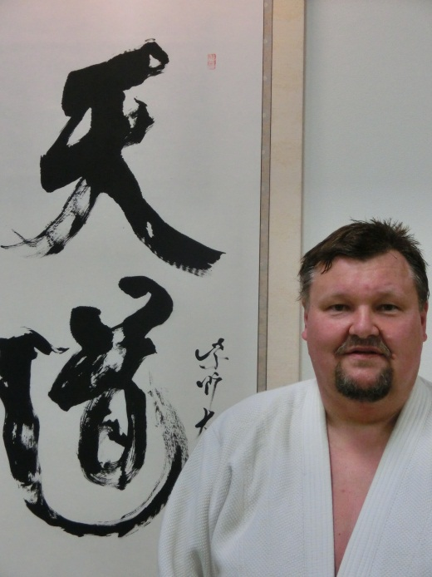
Seminar will be doing in the gym under the Eastern football Stadium, Mladinska ul. 29, 2000 Maribor, Slovenia:
- Saturday 20. May from 10: 30 to 12: 00 and 17: 30 to 19: 00
- Sunday 21. May from 10: 30 to 12: 30

For more information and application we are available to you at,
email: tendoryu.slovenija@gmail.com

