INVITATION
in the context of an educational program for the 2015/16 season Aikido Club Branik Maribor organises Tendoryu Aikido seminar led by international master Mr. Robert Hundshammer 5.DAN from Germany.
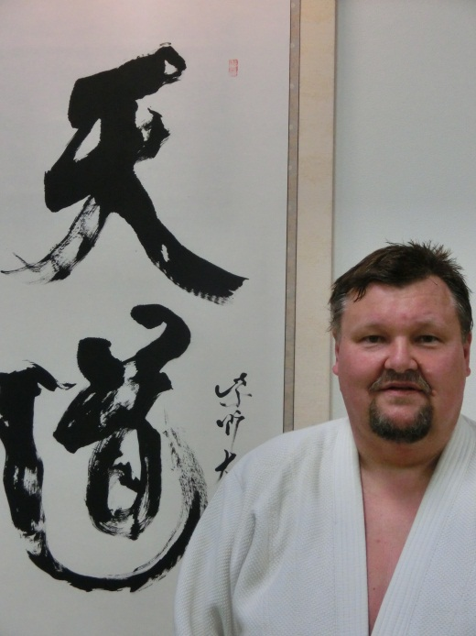
Seminar will be doing in the gym under the Eastern football Stadium, Mladinska ul. 29, 2000 Maribor, Slovenia:
- Saturday 6. June from 10: 30 to 12: 00 and 18: 30 to 20: 00
- Sunday 7. June from 10: 30 to 12: 30

For more information and application we are available to you at,
email: tendoryu.slovenija@gmail.com

